**Brooklyn torah gazette**

**For rosh hashanah 5780**

Volume 4, Issue 1 (Whole Number 153) 1-2 Tishrei 5780/ Sept. 30- Oct. 1, 2019

**Printed L’illuy nishmas Nechama bas R’ Noach, a”h**

For a free subscription, please forward your request to [***keren18@juno.com***](mailto:keren18@juno.com)

**Rav Avigdor Miller On Learning What's Important Before Time Runs Out**

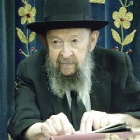

**QUESTION:** Can the Rav give us some specific advice for us to work on in order to be zoicheh ba'din this week?

**ANSWER:** What advice can I give you as hachanah, preparation for Rosh Hashanah?! I was speaking about this for the last hour [Tape E-247 "Greater Than the Universe"]. You have to learn what's important in the eyes of Hashem. Learn what's really important. That's the hachanah for Rosh Hashanah.

"And this is the one that I look at, someone who is of poor and humble spirit, and who trembles before My word" (Yeshai'ah 66:2).*"*Chareid*"*means Orthodox - a chareidi. If you're a frum Jew, that's what's important in the eyes of Hashem. It's not just אגב אורחא . You have to learn that. It's not enough to say it. You have say it so many times that you begin to believe it. The frum Jew is the most important thing in the eyes of Hashem.

The Nobel Prize is not important. The Vice President is not important. Suppose they would offer you the Nobel Prize. It means nothing. And it would be a sakanah [spiritual danger].It would make you crazy for nothing.

Look what happened to Senator Lieberman. Now, Lieberman says that intermarriage is permissible. Can you imagine such a thing? He wants to be Vice-President and all of a sudden intermarriage is mutar. The idea of being Vice-President can turn any body's head. It's a סכנה.

The Noble Prize is a סכנה*.* Because you're being chosen for what the world makes out to be important. But, boruch Hashem, Hakodosh Boruch Hu says to us, "I have chosen you for something really important. I have made you my beloved ones." *"בנים אתם להשם אלוקיכם."* "You are my children," says Hashem.

And knowing that, is the first step in preparing for Rosh Hashanah. And that should be enough for you to decide that you're going to do the will of Hashem. That's the הכנה for Rosh Hashanah - to think about what's important in the eyes of Hashem. To do the רצון השם according to what He told us in His Torah.

Of course, in order to know that, you'll have to listen. People today don't know what Torah is. I'm speaking about the frumma. They don't know what the Torah is saying. You have to listen to what the Torah is teaching us and you have to know all the details. You have to learn the details as much as you can.

You can't do teshuva if you don't know which direction to turn. If a person wants to travel someplace, he has to have some details in order to set out. Say he leaves New York but he doesn't know which direction to go - North or South. It's not enough to just leave in your car and start driving out of the city. Where are you going to?! *"לא ידע ללכת אל עיר."* He doesn't know to which town he has to go to, to do teshuva.

You have to know how to do teshuva. It's not an easy task. You have to learn what Hakodosh Boruch Hu wants from you. It's not enough to just rely on what you remember from your Rebbi in cheder. It's not enough to hear a drasha on Shabbos Shuva. You have to learn the details of developing a Torah mind.

So if you listen to Hakodosh Boruch Hu's words you'll succeed. And you'll find them in the Mesillas Yesharim. Mesillas Yesharim is an excellent guidebook. Chovos Ha'levavos is an excellent guidebook as well. Sha'arei Teshuva is a wonderful guidebook. You have to learn the seforim. And now is an excellent time to begin.

Don't say, "Someday I'll do it." Do it right now. Right now, because that's what Hashem wants from you.

*Reprinted from the 5777 Rosh Hashanah email of Toras Avigdor (Tape #E-247).*

**My Congregation Prays**

**At Pittsburgh’s Tree**

**Of Life Synagogue.**

***Here’s how we are coping this Rosh Hashanah***

**By Beth Kissileff**

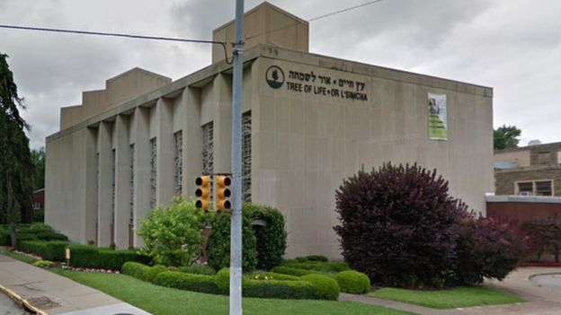

PITTSBURGH ([JTA](http://jta.org/)) — Our sages [teach](https://www.sefaria.org/Iggeret_HaGra.8?vhe=Iggeret_HaGra_--_Wikisource&lang=he) us that “kol hatchalot kashot,” all beginnings are difficult.

This phrase feels especially resonant this [Rosh Hashanah](https://www.myjewishlearning.com/article/rosh-hashanah-101/).

The man who blew the shofar last year at my [Pittsburgh](https://www.jta.org/2018/10/27/united-states/least-4-reported-dead-pittsburgh-synagogue-shooting) synagogue, [New Light](https://newlightcongregation.org/), is not here to blow it now. He was murdered on Oct. 27 at the [Tree of Life synagogue](https://www.treeoflifepgh.org/), where the New Light and [Dor Hadash](http://dorhadash.net/) congregations rented space.

The sounds of the [shofar](https://www.myjewishlearning.com/article/shofar/), which Ashkenazi Jews have a custom of blowing in synagogue the entire month of Elul, have a different resonance to me now. The [Sefer Hachinuch](https://www.sefaria.org/Sefer_HaChinukh.405.5?ven=Sefer_HaChinukh,_translated_by_Sefaria,_2018&lang=bi) explains that “the Torah commanded us to make a sound similar to wailing” when we blow it.

That won’t be hard; there is plenty to wail about this year.

The Sefer Hahinuch adds, “Since a person is physical, he is only aroused by something that arouses, like the way of people during wartime [to] blow and even scream in order that they should be properly aroused for war … and the voice of the shofar arouses the heart of all its listeners … when he hears the broken sounds, he breaks the evil inclination of his heart for the desires of the world and his cravings.”

We need to hear this wailing, and be induced to wail ourselves, so that we can change.

The Talmud ([Rosh Hashana 33b](https://www.sefaria.org/Rosh_Hashanah.33b?lang=bi)) associates these sounds with the wailing of a bereaved mother of an enemy general. In [Judges 5:28](https://www.sefaria.org/Judges.5.28?lang=bi), the mother of Sisera wails that her son has not yet returned from battle, nor returned with any captive women or spoils.

It is hard to know how to interpret this. Even though Sisera’s mother is awful in glorifying her murderous son, she is still a mother and still has compassion for her son — it is that human piece of her we are told to identify with. Perhaps Sisera’s mother is wailing out of sheer human instinct. Her wailing is a sign that she knows that her son will never return, though her words, possibly spoken out of false bravado, suggest otherwise.

The guttural scream of someone trying to comprehend that life will be lived without a loved one is sheer terror. I hope never to hear it again. I have been with families at the moment they received official notification from the FBI of their loved one’s deaths. Though they knew in their hearts that their loved one was gone when they did not hear from them hours before, the moment of irrevocable understanding that they will never see their loved one again is a dreadful one.

But sometimes the deepest pain can also bring healing.

The concept of [post-traumatic growth](https://www.apa.org/monitor/2016/11/growth-trauma) is a psychological theory about transformation after trauma. It shows that people who undergo significant trauma can emerge from the experience with an improved appreciation for life, relationships with others, personal strength and spiritual growth. This does not remove the many challenges and anxieties connected to coping with trauma, but adds that growth is possible, too.

When we hear the shofar, if we hear it as a wail and scream, perhaps we can change our lives and make what comes after Rosh Hashanah irrevocably different from what comes before.

I have seen it happen in my own community. People have changed over the course of the year. Some have made and kept commitments to attend synagogue more regularly. Some of our new haftarah chanters have not used the skill since bar mitzvah, if ever, but are committed to reading every few weeks in honor of our three devoted haftarah readers at New Light — Dan Stein, Rich Gottfried and Mel Wax — who are no longer able to chant the prophetic words. There are those who did not have much interest in the spiritual side of Judaism who now attend any classes we hold. People who have always wanted to learn Hebrew have been studying it for the first time.

This Rosh Hashanah, all American Jews, shocked to our core at the resurgence of violent anti-Semitism here — a country to which our ancestors immigrated as a haven from such things in the rest of the world — will hear the shofar as a wail and scream. We have undergone the deeply painful trauma of knowing that in Pittsburgh and [Poway,](https://www.jta.org/2019/04/29/united-states/poway-a-california-haven-learns-it-can-happen-here) Jews have been murdered solely because they are Jews.

However, this deep trauma we have experienced also means we can and need to think about how as a community we can attempt to work through the trauma to achieve meaningful growth.

It is not uncomplicated, but Rosh Hashanah is coming, and we all have the opportunity to begin again — however difficult.

Reprinted from the September 19, 2019 dispatch of the JTA (Jewish Telegraphic Agency).

**Symbolism of the Shofar**

**By Rabbi Shraga Simmons**

During the blowing of the shofar on Rosh Hashana, notice there are three distinct sounds:

*Tekiah* – one long, straight blast

*Shevarim* – three medium, wailing sounds

*Teruah* – 9 quick blasts in short succession

**Hear the Shofar Sounds**

Let's examine each of these shofar sounds, and see how they relate to the different themes of Rosh Hashana.

**THE TEKIAH SOUND**

Rosh Hashana is the day of appreciating who G-d is. We then internalize that understanding so that it becomes a living, practical part of our everyday reality. G-d is all-powerful. G-d is the Creator. G-d is the Sustainer. G-d is the Supervisor. In short, G-d is King of the Universe.

But for many of us, the idea of a "king" conjures up images of a greedy and power-hungry despot who wants to subjugate the masses for his selfish aims.

In Jewish tradition, a king is first and foremost a servant of the people. His only concern is that the people live in happiness and harmony. His decrees and laws are only for the good of the people, not for himself. (see Maimonides, Laws of Kings 2:6)

The object of Rosh Hashana is to crown G-d as our King. *Tekiah* – the long, straight shofar blast – is the sound of the King's coronation (Malbim – Numbers 10:2). In the Garden of Eden, Adam's first act was to proclaim G-d as King. And now, the shofar proclaims to ourselves and to the world: G-d is our King. We set our values straight and return to the reality of G-d as the One Who runs the world... guiding history, moving mountains, and caring for each and every human being individually and personally.

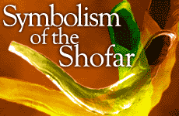

*The quintessential symbol of Rosh Hashana is more than just a primitive trumpet.*

Maimonides adds one important qualification: It isn't enough that God is MY King alone. If ALL humanity doesn't recognize G-d as King, then there is something lacking in my own relationship with G-d. Part of my love for the Almighty is to help guide all people to an appreciation of Him. Of course this is largely an expression of my deep caring for others. But it also affects my own sense of G-d's all-encompassing Kingship.

**THE SHEVARIM SOUND**

When we think about the year gone by, we know deep down that we've failed to live up to our full potential. In the coming year, we yearn not to waste that opportunity ever again. The Kabbalists say that *Shevarim* – three medium, wailing blasts – is the sobbing cry of a Jewish heart – yearning to connect, to grow, to achieve. (Tikunei Zohar – 20-21, 49a)

Every person has the ability to change and be great. This can be accomplished much faster than you ever dreamed of. The key is to pray from the bottom of your heart and ask G-d for the ability to become great. Don't let yourself be constrained by the past. You know you have enormous potential.

At the moment the shofar is blown, we cry out to G-d from the depths of our soul. This is the moment – when our souls stand before the Almighty without any barriers – that we can truly let go.

**THE TERUAH SOUND**

On Rosh Hashana, we need to wake up and be honest and objective about our lives: Who we are, where we've been, and which direction we're headed. The *Teruah* sound – 9 quick blasts in short succession – resembles an alarm clock, arousing us from our spiritual slumber. The shofar brings clarity, alertness, and focus. (Malbim – Yoel 2:1)

The Talmud says: "When there's judgment from below, there's no need for judgment from above." What this means is that if we take the time to construct a sincere, realistic model of how we've fallen short in the past, and what we expect to change in the future, then G-d doesn't need to "wake us up" to what we already know.

G-d wants us to make an honest effort to maximize the gifts He gave us. You aren't expected to be anything you're not. But you can't hoodwink G-d, either.

The reason we lose touch and make mistakes is because we don't take the time every day to reconnect with our deepest desires and essence. The solution is to spend time alone every day, asking: Am I on track? Am I focused? Am I pursuing goals which will make the greatest overall difference in my life and in the world? (See Personal Growth Worksheets)

Make it a habit to keep in touch with yourself, and when Rosh Hashana comes around, the alarm clock of the shofar won't be nearly as jarring!

*Reprinted from the website of Aish.com*

**Rabbi Berel Wein**

**On Rosh Hashanah**

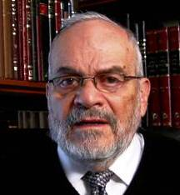

**Rabbi Berel Wein**

The concept of beginning a new year, of giving the new year a different number than that of the year just past, is an essential part of human nature. All human beings desire the ability to begin anew as well as to have an opportunity to reflect on accomplishments and achievements.

If we live in a constant cycle of time without the blessings of new beginnings, life would be depressing and almost hopeless. We would always be carrying with us the baggage of previous times and errors of judgment and behavior. It would be like having a book that would not allow us to turn its pages.

As such, we find that in all societies of humans that inhabit this globe, the concept of a new year has taken a strong hold. Original humans and many indigenous tribes and peoples did not have the concept of a yearly calendar. Time was an unending stream that knew no boundaries or limitations.

Such a view of life and events limits one's ability to gain introspection into the behavior patterns of life and of entire societies. One of the great contributions of the Torah was to establish a calendar based on the measurement of time in terms of years, months, weeks and even days.

The author of Psalms taught us that we are to number our days so that we will be able to obtain a heart of wisdom. For without the ability to measure the passage of time, there can be little reflection or deep understanding of life’s events and a true appreciation of the learning process which life itself represents.

Perhaps this is the basic lesson that the great holiday of Rosh Hashana teaches us. It marks a fine delineation in our life experience, and it points the way not only to a review of the past but also to a renewed commitment for a better future.

The sound of the shofar awakens us to the reality of the passage of time and challenges us to make proper use of this great gift. There are different notes that are sounded by the shofar, as they represent different experiences of past life and indicate the challenges that future life always encompasses. Human beings, by nature, are reticent to face up to past errors or to contemplate future challenges even though they are often predictable and many times unavoidable.

The nature of this great holiday is to counteract that reluctance and force us to have a realistic view of the past and future, to adjust ourselves to these realities and to create solutions that will enable us to overcome difficult problems in our personal and national life.

The holiday itself is a hybrid creation of contentment, good food, family gathering and confidence as to our future. But it is also a day of awe and inner concern, of uncertainty and tension and one of deeply felt intense prayer. All these emotions, contradictory as they may seem and perhaps really are, are combined in our celebration of this great day that the Lord has granted to us.

There are many customs related to the holiday of Rosh Hashana that have evolved over the millennia. All these customs combine within them the two opposite emotions that characterize this new year holiday. We eat sweet food and honey and hope for a year of physical and spiritual renewal. Yet, we gather to cast away our sins in pools of water to symbolize the necessity for our self-improvement in the coming year.

It is therefore a day of regret, though we do not allow such expressions to appear in our prayer service, for our focus is upon the future and not on the past.  But we are all aware that our past always accompanies us and reminds us of our strengths and weaknesses, of our potential and of our goals.

So, once again, the words of the Psalmist to rejoice in the trembling, accurately describes our feelings and emotions on this day of celebration and judgment. The majesty of the prayer service of this day is unmatched, so to speak, in all human expression.

Contemplation and understanding of the service itself creates within us the mood and sets tone of the day, to encourage us to move forward in confidence into the new and blessed year that is now beginning.

*Reprinted from this week’s website of Rabbiwein.com*

**Let’s Make a Difference**

**By Rabbi Moshe Meir Weiss**

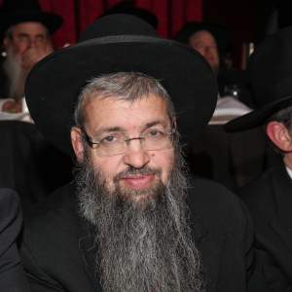

As we march closer to Rosh HaShannah, the Jewish Day of Judgement, the wise person prepares for this critical encounter with the Divine Judge.  One of the best defenses that one can muster is to make oneself needed by as many people as possible.

The Gemora teaches us “HaOlam nidon bis kiraachas – The world is judged with one sweeping, global overview.” This means that besides inspecting everyone individually, Hashem also takes a look at how all of the pieces of humanity interlock, one with another, and if someone is needed by many people and they don’t deserve to lose him, then he or she is granted another year even if they personally don’t deserve it because of sin or spiritual lethargy.

The Gemora teaches us this all-important concept when it discusses the tragic death of the great tzadikim, Nadav and Avihu, the children of Aharon HaKohein.  The Gemora questions why these great people died at the Hands of Hashem.

The Gemora answers that it was because they weren’t married and because they had no children.  This is mystifying since the Torah itself says that they were executed by laser like beams which emanated from the Holy of Holies because theyintroduced a foreign fire on the mizbei’ach, the altar, during the week of the Tabernacle’s inauguration.

So, how can the Gemora advance a different reason than that whichHashem tells us in the Gemora?  The commentators almost unanimously explain that indeed the reason for Nadav and Avihu’s death was because of their extracurricular fire-offering.  However, if they had been married, the fact that their wives would have needed them would have saved them.

Furthermore, even if they no longer had wives, the Gemora advances further, if they had had children, the children would have saved them. In a similar vein, the ChasamSofer, Zt”l, Zy”a, interprets the verse, “V’hosircha Hashem bifribitnicha – Hashem will give you extra because of the fruit of your womb,” to mean that if a person stays active in the tutelage of their grandchildren and great-grandchildren, this will add years to their life because they are needed to ensure the passing of the Torah legacy to their descendants.

A great example of how one person can make themselves needed by the masses is the wondrous life of the late RebbetzinJungreis, Zt”l, Zy”a.  Readers of the Jewish Press, for the last half-century, are well aware of the impact the she made in their lives.  In thousands of living rooms across the globe, Friday nights have been illuminated by her sage advice and inspiration for more the five decades.Each of us, in our own way, needs to realize that we can make a difference.  But, we must be conscious to make this effort.

Once in a great while, the Jewish Press has to ‘bump’ an article because of lack of space. When my column is omitted, I complain through my wonderful agent, Shelley Zeitlin, to the trusted Senior Editor, Jason Maoz. He responds, ‘Tell Rav Weiss that now he’s ahead for next week.” But I respond,‘By leaving out my column, tens of thousands of people will not learn its Torah this Shabbos.’  To me, that is a reality of how I can impact as many people as possible.

I know my readers will be thinking ‘What does this have to do with me? I don’t have a column in a major newspaper. But the way we answer “amein” in shul encourages those around us to do the same.  So too, when we are quiet by davening or when we come on time for davening, when we are courteous to everyone in the office, when we take the lead in demonstrating charitable pledges, when we exhibit respect to our spouses, when we are a role model on how we watch our children in shul, we are making a difference – and we are acquiring a strong cloaking mechanism of defense.

I’ve mentioned many times the Orchos Chaim l’HaRavLuniel, Zt”l, Zy”a, who states,“Harotzehl’harichyomim, heveimarbehb’achimv’rei’im – If you want to live long, have many relatives and friends.” For, if we are needed by the lowly and the downtrodden, the impoverished and the vulnerable, or even if we are a staunch friend to another, that is a huge reason for Hashem to extend our lease on life.

So, let’s start getting involved in our shuls, schools, with our relatives, let’s make new friends and help them and in that merit mayHashem bless us all with a New Year of good health, happiness and everything wonderful.

*Reprinted from the September 14, 2016 website of Matzav.com*

**The Shmuz onRosh Hashanah**

**The Extent of**

**Hashem’s Mercy**

**By Rabbi Bentzion Shafier**

**Founder of TheShmuz.com**

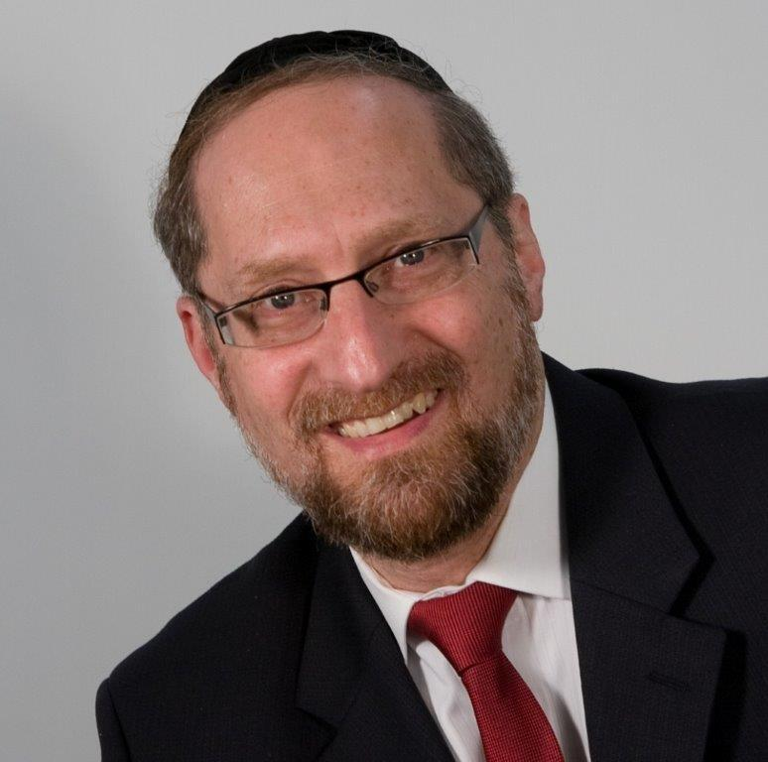

The story of *Bilam*, the gentile prophet, is most peculiar. It begins when *Balak*, the king of Moav, recognizes that he is in danger. The Jewish Nation had just destroyed *Sichon,* and *Moav* was next. Out of desperation, *Balak* sent messengers to *Bilam,* saying, “Please, curse this nation so that we can remain in our land.”

*Bilam* was more than willing to curse the Jews–he hated them more than *Balak* did*,* explains Rashi. *Balak* only asked for help defending himself against the Jews. *Bilam* wanted them dead. Therefore, *Bilam* asked HASHEM for permission to destroy the Chosen Nation.

HASHEM said to *Bilam*, “You may go, but do not say anything I don’t tell you to say.” *Bilam* then set off with his donkey on a journey to curse the Jews. Along the way, a *moloch* stopped the donkey. *Bilam* beat it. The donkey continued. Again a *moloch* stopped it, and again *Bilam* beat it. Finally, the donkey opened its mouth and spoke. An overt miracle.

The *Siforno* explains that Hashem brought this miracle so that *Bilam* should realize his mistake and do *teshuvah*. Even though Hashem doesn’t normally create obvious miracles, He nevertheless did here because He didn’t want a man as important as *Bilam* to be lost.

**Putting This into Perspective**

This *Siforno* is difficult to understand. Can we imagine anyone more evil than *Bilam*? He was gifted with the status of a *navi*, thereby granted a fantastic power: the ability to bless or curse. His words were potent. He was now going to use his power to annihilate a people. His intentions were to wipe out the Jews—every man, woman, and child. And he would have succeeded had Hashem not stopped him. This is a man on the level of an Adolph Hitler.

Why would Hashem allow such a man to do *teshuva*? And even more, why would HASHEM change nature to save such a lowlife?

To answer this question, we need a different perspective.

**What Did You Do To Be Worthy of Being Created?**

The *Chovos Ha'Levovos* says that a person should ask himself the following question: before I was created, what did I do that made me worthy of being created? I recognize that I didn’t exist and that Hashem made me. It must be that HASHEM felt that it was worthy to bring me into being. What is it that I did that made me worthy of being created?

The answer is nothing. Because before you were created, you weren’t. And that is the point. There is nothing you did to make it fit for Hashem to create you. Hashem made you because of lovingkindness.

HASHEM is *the* Benefactor. HASHEM wishes to give. Generous and magnanimous, HASHEM wishes to shower His good upon others. Not because they deserve it, and not because they merit it, but because that is the nature of HASHEM: to bestow as much blessing as He can. HASHEM created everything—the stars, the sun, the moon, the oceans, and the rivers—to give to man.

Man, however, has to earn that good. To do so, he must perfect himself. HASHEM is the source of all perfection. HASHEM put man into this world charged with the mission of making himself as much like HASHEM as humanly possible. When man is finished his job here, he enjoys closeness to HASHEM in accordance to the amount that he perfected himself here.

That, however, is the inherent obstacle. HASHEM is beyond time, beyond space, and beyond any limitation. By definition, HASHEM is beyond human understanding. HASHEM wants man to emulate Him—but that is impossible.

To allow for this, HASHEM manifests Himself cloaked in character traits. Those traits guide HASHEM’s interaction with the world. Now, based on how HASHEM acts, man can see Him.

**Justice versus Mercy**

HASHEM originally thought to create the word with *Din* (justice) as the guiding attribute. *Din* is proper. *Din* is appropriate. *Din,* however*,* demands total accountability. *Din* demands absolute responsibility. And, *Din* demands immediate consequences. You are liable for what you did. No excuses. No mitigating circumstances. You brought this about–this is the result.

If *Din* were the operating attribute, no human could exist. Man will err. Man will slip. Therefore, HASHEM created the world with *Rachamim* (mercy) as the predominant force. Now, our actions are viewed through the lens of understanding. Mitigating circumstances are taken into consideration, and time is granted. Time to recognize our errors. Time to correct our ways.

Therefore, HASHEM manifests Himself in the almost human character trait of mercy–the key word being *almost*. HASHEM is not human. And HASHEM is not restricted. When HASHEM wears an attribute, it is endless and boundless. When Hashem wears the attribute of mercy, it has no limit.

**The Extent of HASHEM’S Mercy**

This seems to be the answer to *Bilam*. Granted he was wicked, and granted he set out to use his gifts for evil, but HASHEM still wished for his good. HASHEM still loved him. Despite everything he was planning to do, HASHEM didn’t want him destroyed. And so, HASHEM tried guiding him to *teshuvah* even if that meant changing nature and making a donkey speak.

There is a vital lesson for us in these words. *Bilam* was a gentile – a gentile who turned to wicked ways. Yet HASHEM still waited for his *teshuvah*. How much more so for us, the children of *Avraham*, *Yitzchak* and *Yaakov*? We are HASHEM’s nation. We are His beloved. HASHEM waits with open arms, saying, “Return, My children. Return.”

*Reprinted from this week’s website on TheShmuz.com This is an excerpt from the [Shmuz on the Parsha book](https://theshmuz.com/product/shmuz-on-the-parsha-book/).*

**What Rosh Hashanah**

**Says to Us**

**By**[**Rabbi Lord Jonathan Sacks**](https://www.aish.com/authors/48865787.html)



***10 essential insights that go to the heart of Judaism.***

What then does Rosh Hashanah say to us? How can it transform our lives? The genius of Judaism was to take eternal truths and translate them into time, into lived experiences. Rosh Hashanah, the anniversary of the creation of humanity, invites us to live and feel the human condition in graphic ways.

**The first thing** it tells us is that life is short. However much life expectancy has risen, we will not, in one lifetime, be able to achieve everything we might wish to achieve. *Untaneh Tokef* tells the poetry of mortality with haunting pathos:

Man is founded in dust and ends in dust. He lays down his soul to bring home bread. He is like a broken shard, like grass dried up, like a faded flower, like a fleeting shadow, like a passing cloud, like a breath of wind, like whirling dust, like a dream that slips away.

This life is all we have. How shall we use it well? We know that we will not finish the task, but neither are we free to stand aside from it. That is the first truth.

**The second** is that life itself, each day, every breath we take, is the gift of G-d:

Remember us for life, O King who delights in life, and write us in the book of life – for Your sake, O G-d of life. (*Zikhronot*)

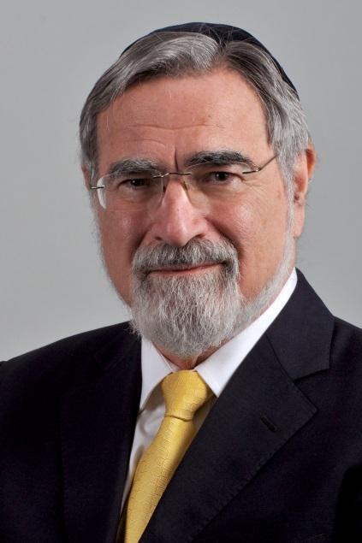

[**Rabbi Lord Jonathan Sacks**](https://www.aish.com/authors/48865787.html)

Life is not something we may take for granted. If we do, we will fail to celebrate it. G-d gives us one gift above all others, said Maimonides: life itself, beside which everything else is secondary. Other religions have sought G-d in heaven, or in the afterlife, the distant past or the distant future.

Here there is suffering, there reward; here chaos, there order; here pain, there balm; here poverty, there plenty. Judaism has relentlessly sought G-d in the here-and-now of life on earth. Yes, we believe in life after death, but it is in life before death that we truly find human greatness.

**Third,** we are free. Judaism is the religion of the free human being freely responding to the G-d of freedom. We are not in the grip of sin. We are not determined by economic forces or psychological drives or genetically encoded impulses that we are powerless to resist.

The very fact that we can do *teshuva*, that we can act differently tomorrow than we did yesterday, tells us we are free. Philosophers have found this idea difficult. So have scientists. But Judaism insists on it, and our ancestors proved it by defying every law of history, surviving against the odds, refusing to accept defeat.

Fourth, life is meaningful. We are not mere accidents of matter, generated by a universe that came into being for no reason and will one day, for no reason, cease to be. We are here because a loving G-d brought the universe, and life, and us, into existence – a G-d who knows our fears, hears our prayers, believes in us more than we believe in ourselves, who forgives us when we fail, lifts us when we fall and gives us the strength to overcome despair.

The historian Paul Johnson once wrote: “No people has ever insisted more firmly than the Jews that history has a purpose and humanity a destiny.” He concluded: “The Jews, therefore, stand right at the center of the perennial attempt to give human life the dignity of a purpose” (Paul Johnson, A History of the Jews, Prologue). That too is one of the truths of Rosh Hashanah.

**Fifth,** life is not easy. Judaism does not see the world through rose-tinted lenses. The sufferings of our ancestors haunt our prayers. The world we live in is not the world as it ought to be. That is why, despite every temptation, Judaism has never been able to say the Messianic Age has come, even though we await it daily. But we are not bereft of hope because we are not alone. When Jews went into exile, the *Shekhina*, the Divine Presence, went with them. G-d is always there, “close to all who call on Him in truth” (Ps. 145:18). He may hide His face, but He is there. He may be silent, but He is listening to us, hearing us and healing us in ways we may not understand at the time but which become clear in retrospect.

**Sixth,** life may be hard, but it can still be sweet, the way the challah and the apple are on Rosh Hashanah when we dip them in honey. Jews have never needed wealth to be rich, or power to be strong. To be a Jew is to live for simple things: the love between husband and wife, the sacred bond between parents and children, the gift of community where we help others and others help us and where we learn that joy is doubled and grief halved by being shared.

To be a Jew is to give, whether in the form of *tzedaka* or *gemilut ĥasadim* (acts of loving-kindness). It is to learn and never stop seeking, to pray and never stop thanking, to do teshuva and never stop growing. In this lies the secret of joy.

Throughout history there have been hedonistic cultures that worship pleasure and ascetic cultures that deny it, but Judaism has a different approach altogether: to sanctify pleasure by making it part of the worship of G-d. Life is sweet when touched by the divine.

**Seventh**, our life is the single greatest work of art we will ever make. Rabbi Joseph Soloveitchik, in one of his earliest works, spoke about *Ish HaHalakha*, the halakhic personality and its longing to create, to make something new, original. G-d too longs for us to create and thereby become His partner in the work of renewal. “The most fundamental principle of all is that man must create himself.” That is what *teshuva* is, an act of making ourselves anew. On Rosh Hashanah we step back from our life like an artist stepping back from his canvas, seeing what needs changing for the painting to be complete.

**Eighth**, we are what we are because of those who came before us. Our lives are not disconnected particles. We are each a letter in G-d’s book of life. But single letters, though they are the vehicles of meaning, have no meaning when they stand alone.

To have meaning they must be joined to other letters to make words, sentences, paragraphs, a story, and to be a Jew is to be part of the strangest, oldest, most unexpected and counterintuitive story there has ever been: the story of a tiny people, never large and often homeless, who nonetheless outlived the greatest empires the world has ever known – the Egyptians, Assyrians, Babylonians, the Greeks and Romans, the medieval empires of Christianity and Islam, all the way to the Third Reich and the Soviet Union.

Each in turn thought itself immortal. Each has gone. The Jewish people still lives. So on Rosh Hashanah we remember and ask G-d to remember those who came before us: Abraham and Isaac, Sarah, Hannah and Rachel, the Israelites of Moses’ day, and the Jews of every generation, each of whom left some living legacy in the prayers we say or the melodies in which we sing them.

And in one of the most moving verses of the middle section of Musaf we recall the great words said by G-d through the prophet Jeremiah: “I remember of you the kindness of your youth, your love when you were a bride; how you walked after Me in the desert, through a land not sown” (Jer. 2:2).

Our ancestors may have sinned, but they never stopped following G-d though the way was hard and the destination distant. We do not start with nothing. We have inherited wealth, not material but spiritual. We are heirs to our ancestors’ greatness.

**Ninth**, we are heirs to another kind of greatness too, that of the Torah itself and its high demands, its strenuous ideals, its panoply of mitzvot, its intellectual and existential challenges. Judaism asks great things of us and by doing so makes us great. We walk as tall as the ideals for which we live, and those of the Torah are very high indeed.

We are, said Moses, G-d’s children (Deut. 14:1). We are called on, said Isaiah, to be His witnesses, His ambassadors on earth (Is. 43:10). Time and again Jews did things thought impossible. They battled against might in the name of right. They fought against slavery. They showed that it was possible to be a nation without a land, to have influence without power, to be branded the world’s pariahs yet not lose self-respect.

They believed with unshakable conviction that they would one day return to their land, and though the hope seemed absurd, it happened. Their kingdom may have been bounded by a nutshell, but Jews counted themselves kings of infinite space. Judaism sets the bar high, and though we may fall short time and again, Rosh Hashanah and Yom Kippur allow us to begin anew, forgiven, cleansed, undaunted, ready for the next challenge, the next year.

**And finally** comes the sound of the shofar, piercing our defenses, a wordless cry in a religion of words, a sound produced by breath as if to tell us that that is all life is – a mere breath – yet breath is nothing less than the spirit of G-d within us: “Then the L-rd G-d formed man from the dust of the ground and breathed into his nostrils the breath of life, and man became a living being” (Gen. 2:7). We are dust of the earth but within us is the breath of G-d.

And whether the shofar is our cry to G-d or G-d’s cry to us, somehow in that *tekia, shevarim, terua* – the call, the sob, the wail – is all the pathos of the Divine-human encounter as G-d asks us to take His gift, life itself, and make of it something holy by so acting as to honor G-d and His image on earth, humankind.

For we defeat death, not by living forever but by living by values that live forever; by doing deeds and creating blessings that will live on after us; and by attaching ourselves in the midst of time to G-d who lives beyond time, “the King – the living, everlasting G-d.”

The Hebrew verb *lehitpalel*, “to pray,” more precisely means “to judge oneself.” On Rosh Hashanah we stand in judgment. We know what it is to be known. And though we know the worst about ourselves, G-d sees the best; and when we open ourselves to Him, He gives us the strength to become what we truly are.

Those who fully enter the spirit of Rosh Hashanah emerge into the new year charged, energized, focused, renewed, knowing that to be a Jew is to live life in the presence of G-d, to sanctify life for the sake of G-d, and to enhance the lives of others – for where we bring blessings into other lives, there G-d lives.

*Reprinted from the website of Aish.com An excerpt from*[*Ceremony and Celebration: Introduction to the Holidays*](https://www.korenpub.com/koren_en_usd/the-koren-sacks-rosh-hashana-mahzor.html)*by Rabbi Jonathan Sacks*